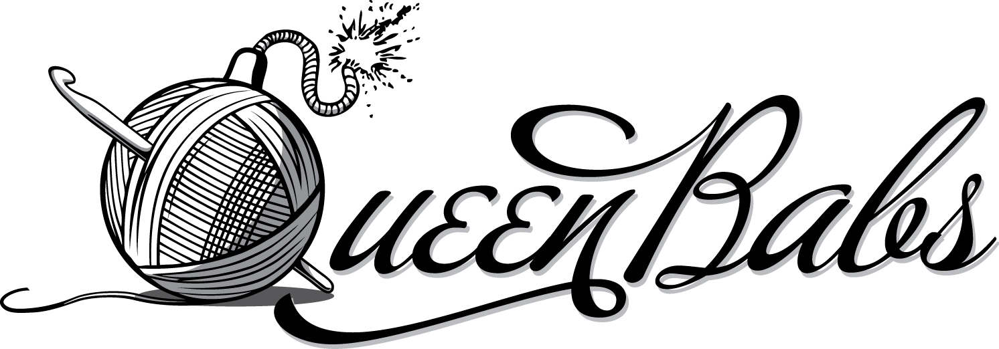
Yarnbombing tips witH

Where should you yarnbomb? When should I yarnbomb?
Don't cover or interfere with safety signs or reflective striping. Avoid places that might cause traffic accidents. Somewhere you can take down any that are wrecked or past their prime. Many do it overnight so it seems to just appear like magic. Depends how visible you want to be.
What should I take in my yarnbombing kit?

- Yarnbomb, scissors, safety pins, needles, yarn, tags, stickers and any labels you want & a step stool or ladder if needed
- a camera, water and snacks, a friend is good and makes it more fun
- your details or card in case someone wants to contact you
- a smile and a a sense of adventure
- And if at night, a torch or even a helmet with a light!!

And now basic How-to Nuts-and-bolts useful info...

1. Measure the object you want to yarnbomb!
Do it accurately. You need the width and the length. When you become addicted you may want to replace it when it fades in a year. Take photo of the thing you want to yarnbomb.
2. What yarn should you use?
I find acrylic lasts the longest and keeps its colour well. I avoid FLURO yarn because it fades very quickly. I avoid fluffy, eyelash or other delicate yarns because they break easily. Whether it is a $2 or $8 ball seems to have little bearing on how tough or colour fast it is. Experiment!

3. Start with something simple!
Look at designs you like and use it to inspire you. Make a rough plan. Make your first yarnbomb close to home so you can see how it survives the weather and your choice of yarn. Also you will find out if locals and government councils want to cut it down or admire it. You may want to seek permission from your local council or authority. If so, do it well ahead of time.

4. What stitches should I use? How do I get the size right?
Beginning and ending stitches should be strong and less stretchy. It is important that you can sew it up and get it to stay up. You might want to make a swatch to test. Over time weather makes the yarnbomb stretch and its own weight makes the yarnbomb stretch too.
Make the base slightly smaller so it stretches firmly to fit. This makes it tighter and more likely to stay put. In crochet, for example my pole is 19cm wide. My tension is medium and stretchy. I make it 17cm and it stretches firmly, but not too tightly out to 19cm. When on the knitting machine, I make it 22cm wide for example, but it shrinks down below 19cm when I take it off the machine.

5. Are you adding decorations?
I sew my decorations on so they can withstand heavy handling as people touch them. Wherever you sew on decorations it will not stretch the same way as plain areas. Large decorations can be sewn on partly before adding to the pole and finished when it is up. Everyone has their own way of sewing on decorations:
- Use tapestry or wool needles.
- I like to lay it out, play and place things on. When I am happy, I take a photo to help me remember my placement. If it's small, I safety pin them on. If it's a big, I try to think in layers so stems down first, sew, then flowers, sew, then leaves etc.
- Some whip stitch them on. I sew through the outside margin with running stitch.

6. Sewing up the yarnbomb to the pole, tree or bike rack.
For crochet, I sew the yarnbomb with double yarn. For knitting, I use a single strands as the double strand stands out too much. I also sew around the top and bottom of the pole a few times to make it very tight and to reinforce the sewing. I use strong 8ply acrylic in matching colours to sew up. Another idea is to add cable or electrical ties to the top, or sew a loop over the top of the pole or tree branch to keep it from falling down.
To keep the rows even I suggest big safety pins to hold the sides together as you work and so you are matching the sides evenly. Just space them out here and there.

7. Adding your name or yarnbomb name.
A laminated tag or cloth tag lets people know about the yarnbomb. I have stickers with my name and details and a laminated tag.
8. Take a photo!
The yarnbomb will not last forever, but a photo is a good record. Share it with your friends and on Facebook or Instagram. There is a thriving community of yarnbombers on Instagram, myself included!

https://www.facebook.com/queenbabscards
http://www.ravelry.com/people/QueenBabsSydney
https://instagram.com/queen_babs/
http://www.redbubble.com/people/queenbabs
http://yarnbombersunited.weebly.com/
https://twitter.com/queen_babs
https://www.pinterest.com/queenbabscards/

Wishing you good luck and happy adventures in your new yarnbombing project! Cheers!
Queen Babs

