KNIT A HEART

I suggest 4mm needles with 8ply and 5mm needles with 10ply.
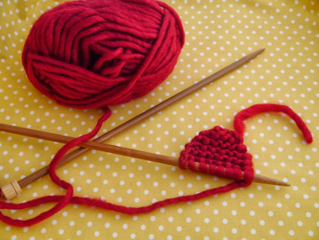
Instructions

Start by knitting the top of the heart – cast on 5 stitches.
Row 1: Knit.
Row 2: Increase the first first stitch by knitting in the front and back (kfb) of the stitch, then knit to the end of the row.
Row 3: Knit.
Row 4: Knit to the last stitch, increase (kfb).
Row 5: Knit.
Row 6: Increase the first first stitch (kfb), knit to the end of the row.
Rows 7-10: Knit.
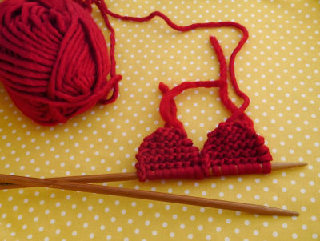
Cut the yarn and push your work to the bottom of the needle.

Now make the other top half of the heart – cast on 5 stitches on the same needle where your work is.
Repeat rows 1-10.

Once completed, the 2 pieces should be on the same needle.

- Join the two pieces by knitting across them.
- Knit 4 more rows.
- On the next row, decrease first and last stitch by knitting 2 stitches together (k2tog).
- Knit the next row.
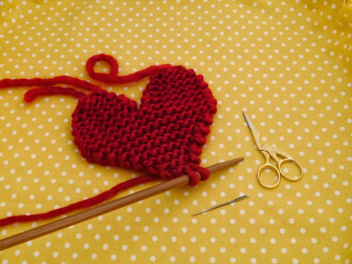
- Repeat the last 2 steps until you have 2 stitches left.
- Cut the yarn off, take your tapestry needle with the yarn through the remaining 2 stitches and weave in all the ends.

