Cherry Blossom Flower by
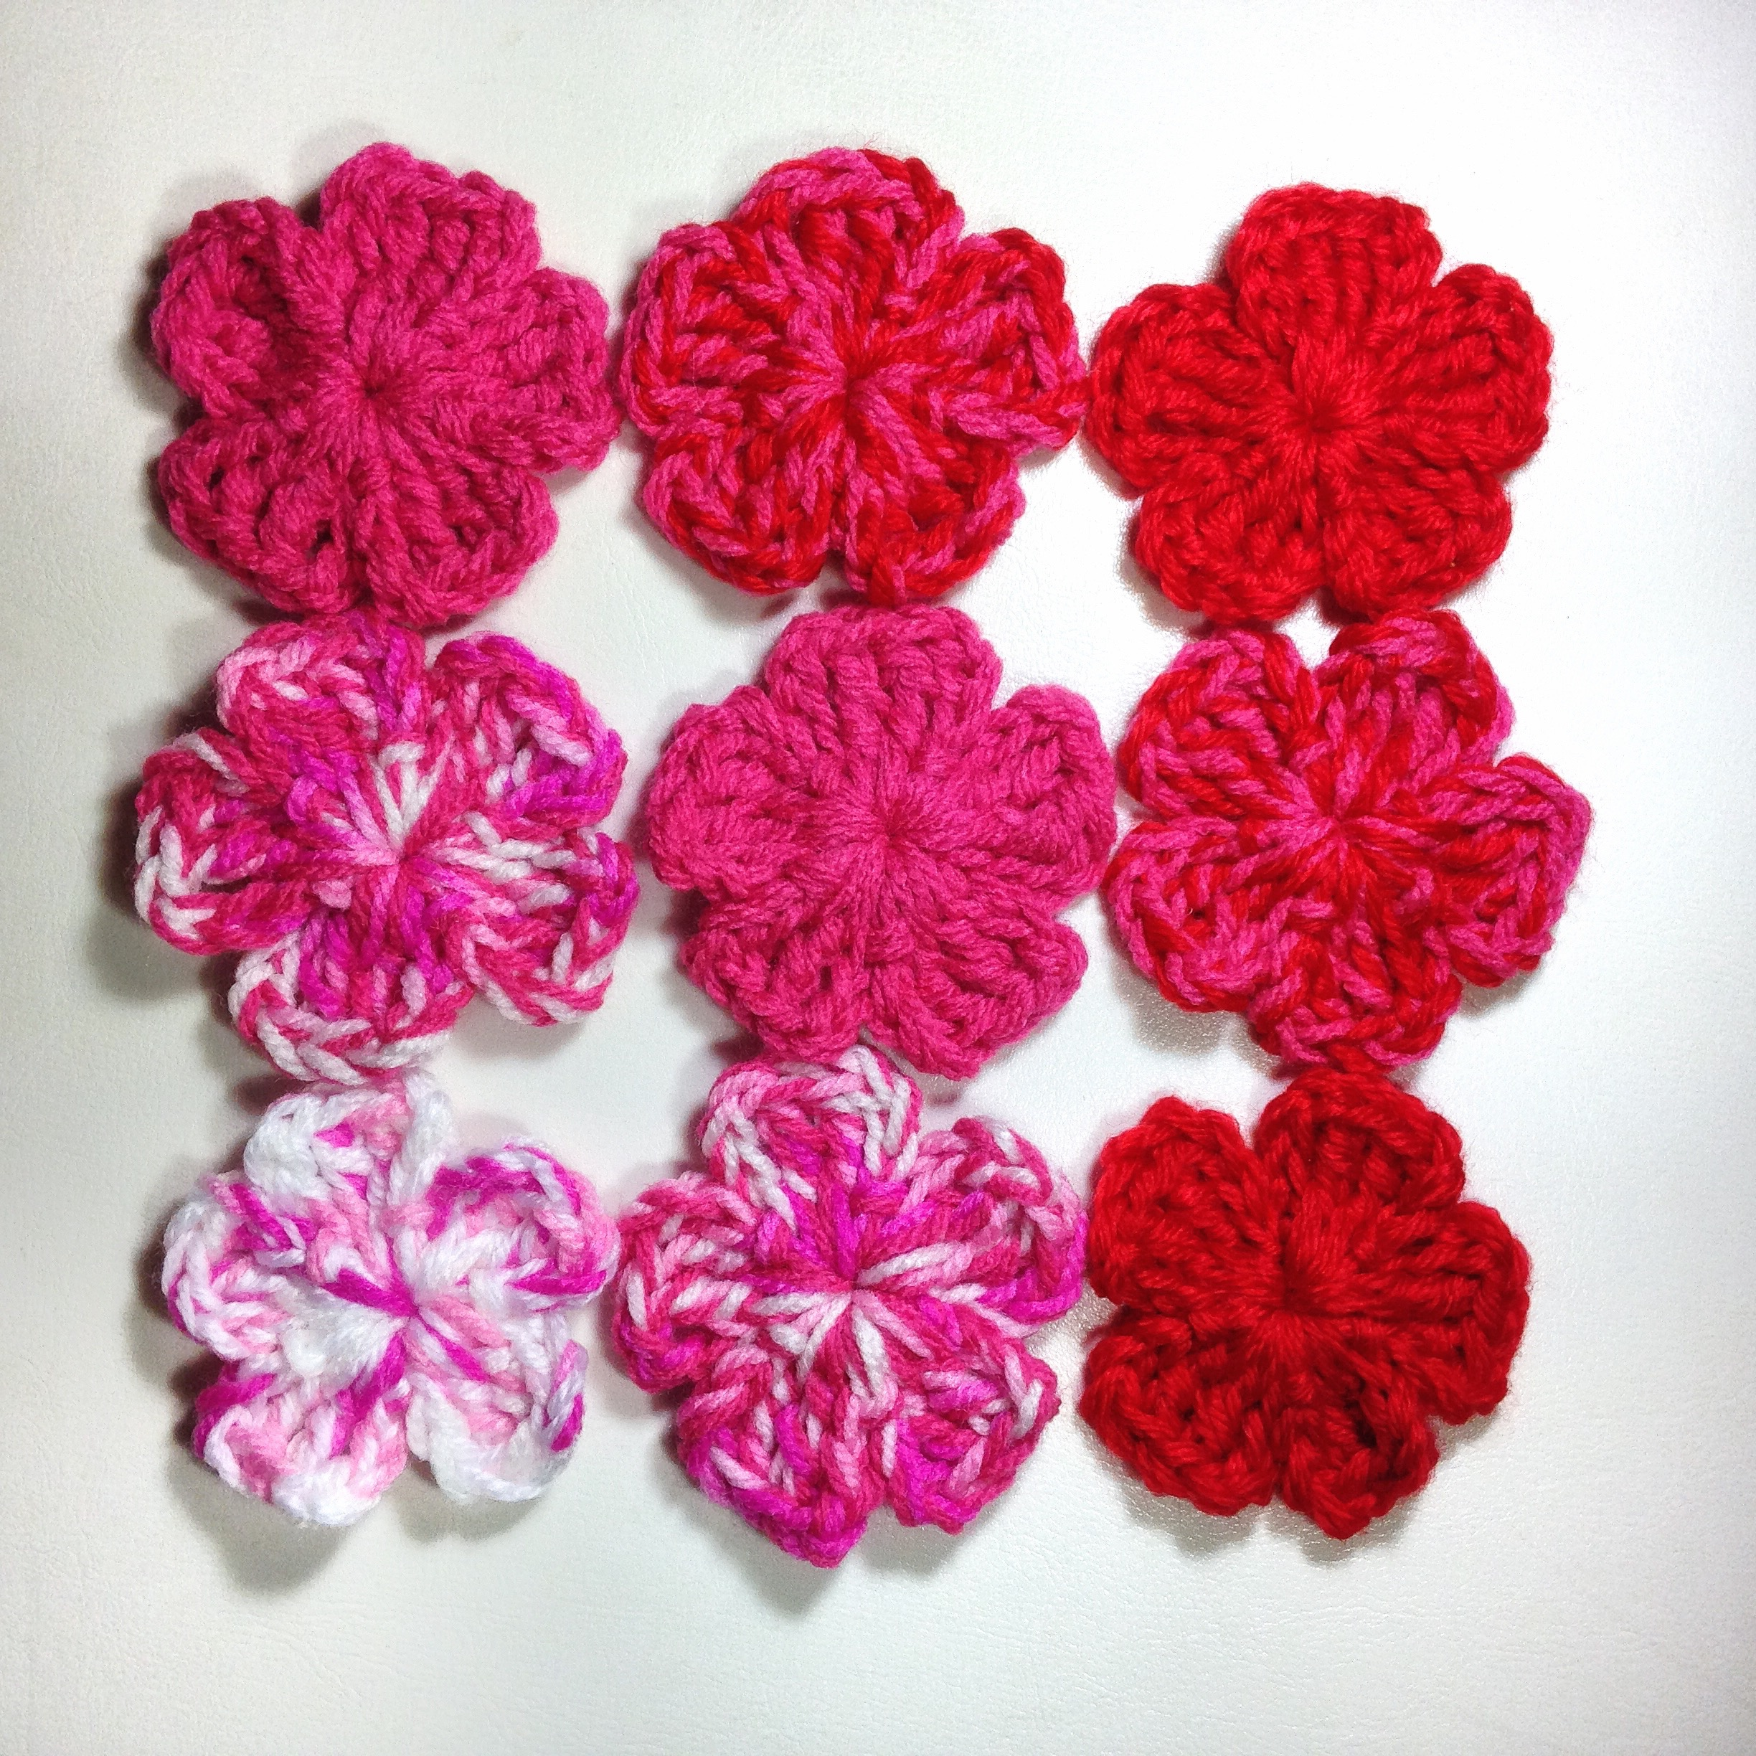

I used 8ply (DK weight) yarn and 4mm hook or use your choice of yarn with matching hook.

You will also need a Yarn needle for finish the flower.

US Terms
Ch - chain
Ss - slip stitch
Sc - single crochet
Hdc - half double crochet
Dc - double crochet
Tc - treble crochet

Flower Pattern

Start with a Magic ring.
(Or ch 3 & ss into ch1. Work in ring.

1. * Ch 4, then work 2 tc into the ring, ch 4, ss into ring. *

2. Repeat from * to * 4 more times so you have 5 petals.

3. Close ring and finish off. Weave in ends.

4. Use contrasting yarn to embroider the centre. Use double yarn in the needle if you want to make it thicker.

Sew up through the centre of the flower and out half way towards the centre edge of the petal. This is shown in the photos above. Thread the needle back through the centre and sew in the next petal out half way to the edge again. Continue around for each of the remaining petals. Finish off. Secure the ends.

You can make a 6 petal flower by adding one more set of ch 4, 2 tc, ch 4.
To make a smaller flower reduce to 4 chains to 3 and trc to dc.

Mini Leaf

Ch 6. Ss in 2nd chain from hook.

Then working down the chain work sc, hdc, dc, 7dc in the next chain (the last chain). You may turn the work as you add the 7 dcs so that you are ready to work the other side of the chain.

Now working along the other side work dc in next chain, hdc in next, sc in next, ss in next and last chain. Fasten off. Weave in ends or keep a long tail to sew to your project.

Enjoy!
Queen Babs

