Pinwheel Mandala by

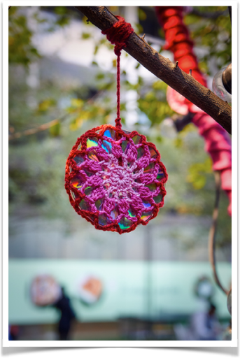

I used 8ply DK yarn and a 4mm hook. Finished mandalas/flowers are under 12cm so they stretch across a cd.

Abreviations - US terms

Ch – chain
Hdc - Half double crochet
Dc – Double crochet
Ss – Slip stitch
St – Stitch
Sp - Space
2Dctg - two double crochet together
3Dctg - three double crochet together

Pattern

With colour 1 begin with ch 4 and ss into the first ch to create a ring.

Round 1
Continuing on…
Ch2 (equals 1 hdc). Work 11 hdc into the ring.
Ss into the top of the top of the ch 2. Continue on.

Round 2
Ch 5 (equals 1 dc & 2 ch). *Work 1dc into the next st, then ch 2.* Repeat from * to * around the circle until you have created 12 spokes. Ss into the 2nd ch (this leaves 2 chs to separate it from the next stitch). Finish off.

Round 3
Attach new colour with a ss in any ch 2 sp.

Ch 3 (equals 1 dc), work 2dctg in the same sp, then ch5. *Work (3dctg, ch 5) into the next sp.* Repeat around the circle creating 12 sets.

Ss into the top of the ch 3. Finish off.

Round 4
Attach new colour with a ss in any ch 5 sp. *Ch 6. Ss in to the next sp.* Repeat from * to * around the mandala.
In the last sp where you began ss into the base of the beginning ch6 of the round. Finish off.
Weave in ends.

For the CD

Make 2 mandalas.
Use the yarn colour on the last round of the cd to finish the CD mandala.

1, Chain a long length of yarn approximately a metre long. Leave 20cm of yarn at both ends for making knots.
2. Place two cds back to back with shiny sides out. Thread the chain through the hole in the middle of the cds. Tie a very secure knot/s around the cd leaving the long tail for hanging and tying it to another object. Trim the end near the cd or sew it in.
3. Place your mandalas right side out on either side of the cds.
4. *Ss under the the ch 6 sp of BOTH mandalas. Ch 6. * Repeat from * to * around the CD, finishing off where you began by ss into the first ch. finish off. Weave in ends.

Your CD Mandala is ready to hang.
​

Whirlwind Mandala by

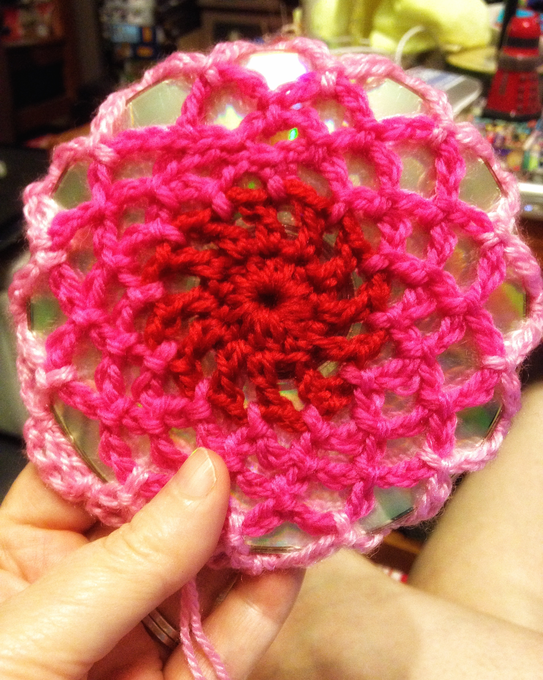

I used 8ply DK yarn and a 4mm hook. Finished mandalas/flowers are under 12cm so they stretch across a cd.

Abreviations - US terms

Ch – chain
Hdc - Half double crochet
Dc – Double crochet
Ss – Slip stitch
St – Stitch
Sp - Space

Pattern
With colour 1 begin with ch 5 and ss into the first ch to create a ring.

Round 1
Continuing on…
Ch3 (equals 1 dc). Work 11 dc into the ring.
Ss into the top of the top of the ch 2. Continue on.

Round 2
Ch 5 (equals 1 dc & 2 ch). *Work 1dc into the next st, then ch 2.* Repeat from * to * around the circle until you have created 12 spokes. Ss into the 2nd ch (this leaves 2 chs to separate it from the next stitch). Finish off.

Round 3
Attach new colour with a ss in any ch 2 sp. *Ch 4. Ss in the next ch2 sp. *
Repeat from * to * around, finishing by ss into the beginning ch. Continuing on...

Round 4
Ss in the next 2 ch of the next 4 ch loop.
*Ch 4. Ss in the next ch 4 sp. *
Repeat from * to * around, finishing by ss into the beginning ch. Continuing on...

Round 5
Ss in the next 2 ch of the next 4 ch loop.
*Ch 5. Ss in the next ch 4 sp. *
Repeat from * to * around, finishing by ss into the beginning ch.

Round 6
Attach new colour with a ss in any ch 5 sp. *Ch 6. Ss in to the next sp.* Repeat from * to * around the mandala.
In the last sp where you began ss into the base of the beginning ch6 of the round. Finish off.
Weave in ends.

For the CD

Make 2 mandalas.
Use the yarn colour on the last round of the cd to finish the CD mandala.

1, Chain a long length of yarn approximately a metre long. Leave 20cm of yarn at both ends for making knots.

2. Place two cds back to back with shiny sides out. Thread the chain through the hole in the middle of the cds. Tie a very secure knot/s around the cd leaving the long tail for hanging and tying it to another object. Trim the end near the cd or sew it in.

3. Place your mandalas right side out on either side of the cds.

4. *Ss under the the ch 6 sp of BOTH mandalas. Ch 6. * Repeat from * to * around the CD, finishing off where you began by ss into the first ch. finish off. Weave in ends.

Your CD Mandala is ready to hang.

